Acute Pancreatitis
Timothy B Gardner, MD, Assistant Professor, Department of Medicine, Dartmouth Medical School; Director of Pancreatic Disorders, Section of Gastroenterology, Dartmouth-Hitchcock Medical Center
Brian S Berk, MD, Assistant Professor, Department of Medicine, Dartmouth Medical School; Director of End Stage Liver Disease, Section of Gastroenterology, Dartmouth Hitchcock Medical Center; Paul Yakshe, MD, Assistant Professor of Medicine, University of Minnesota, Medical Director of Pancreas and Biliary Clinic, Department of Medicine, Division of Gastroenterology, Hepatology, and Nutrition, Fairview University Medical Center
Updated: Jun 10, 2008

Introduction

Background
The pancreas is a gland located in the upper, posterior abdomen and is responsible for insulin production (endocrine pancreas) and the manufacture and secretion of digestive enzymes (exocrine pancreas) leading to carbohydrate, fat, and protein metabolism. Approximately 80% of the gross weight of the pancreas supports exocrine function, while the remaining 20% is involved with endocrine function. The focus of this article is on the exocrine function of the pancreas.
As mentioned, the principal function of the exocrine pancreas is to make food-digesting enzymes. The pancreas, comprising only 0.1% of total body weight, has 13 times the protein-producing capacity of the liver and the reticuloendothelial system combined, which make up 4% of total body weight. Enzymes are produced within the pancreatic acinar cells, packaged into storage vesicles called zymogens, and then released via the pancreatic ductal cells into the pancreatic duct, where they are secreted into the small intestine to begin the metabolic process.
In normal pancreatic function, up to 15 different types of digestive enzymes are manufactured in the rough endoplasmic reticulum, targeted in the golgi apparatus and packaged into zymogens as pro-enzymes. When a meal is ingested, the vagal nerves, VIP, GRP, secretin, CCK, and encephalins stimulate enzymatic release into the pancreatic duct. The pro-enzymes travel to the brush border of the duodenum, where trypsinogen, the pro-enzyme for trypsin, is activated via hydrolysis of an N-terminal hexapeptide fragment by the brush border enzyme enterokinase. Trypsin then facilitates the conversion of the other pro-enzymes to their active form.
A feedback mechanism exists to limit pancreatic enzyme activation after appropriate metabolism has occurred. It is hypothesized that elevated levels of trypsin, having become unbound from digesting food, lead to decreased CCK and secretin levels, thus limiting further pancreatic secretion.
Because premature activation of pancreatic enzymes within the pancreas leads to organ injury and pancreatitis, several mechanisms exist to limit this occurrence. First, proteins are translated into the inactive pro-enzymes. Later, posttranslational modification of the Golgi cells allows their segregation into the unique subcellular zymogen compartments. The pro-enzymes are packaged in a paracrystalline arrangement with protease inhibitors.
Zymogen granules have an acidic pH and a low calcium concentration, which are factors that guard against premature activation until after secretion occurs and extracellular factors trigger the activation cascade. Under various conditions, these protective mechanisms are disrupted, resulting in intracellular enzyme activation and pancreatic autodigestion, leading to acute pancreatitis.

Pathophysiology
Acute pancreatitis may occur when factors involved in maintaining cellular homeostasis are out of balance. The initiating event may be anything that injures the acinar cell and impairs the secretion of zymogen granules, such as alcohol use, gallstones, and certain drugs. At this time, it is unclear mechanistically exactly what pathophysiologic event triggers the onset of acute pancreatitis. However, it is believed that both extracellular factors (eg, neural response, vascular response) and intracellular factors (eg, intracellular digestive enzyme activation, increased calcium signaling, heat shock protein activation) play a role. In addition, acute pancreatitis can develop when ductal cell injury leads to delayed or absent enzymatic secretion, such as with the CFTR gene mutation.
Once a cellular injury pattern has been initiated, cellular membrane trafficking becomes chaotic, with the following deleterious effects: (1) lysosomal and zymogen granule compartments fuse, enabling activation of trypsinogen to trypsin; (2) intracellular trypsin triggers the entire zymogen activation cascade; and (3) secretory vesicles are extruded across the basolateral membrane into the interstitium, where molecular fragments act as chemoattractants for inflammatory cells. Activated neutrophils then exacerbate the problem by releasing superoxide (the respiratory burst) or proteolytic enzymes (cathepsins B, D, and G; collagenase; and elastase). Finally, macrophages release cytokines that further mediate local (and, in severe cases, systemic) inflammatory responses. The early mediators defined to date are tumor necrosis factor-alpha, interleukin-6, and interleukin-8.
These mediators of inflammation cause an increased pancreatic vascular permeability, leading to hemorrhage, edema, and eventually pancreatic necrosis. As the mediators are excreted into the circulation, systemic complications can arise, such as bacteremia due to gut flora translocation, acute respiratory distress syndrome, pleural effusions, gastrointestinal hemorrhage, and renal failure. The systemic inflammatory response syndrome can also develop, leading to the development of systemic shock. Eventually, the mediators of inflammation can become so overwhelming to the body that hemodynamic instability and death ensue.

Frequency

United States
In 2007, nearly 220,000 patients with acute pancreatitis are expected to be admitted to non-federally funded hospitals. In 1998, 183,000 patients with acute pancreatitis were admitted. This trend in rising incidence has been recognized over the past several decades.

International
In Luneburg, Germany, the incidence is 17.5 cases per 100,000 people. In Finland, the incidence is 73.4 cases per 100,000 people. Similar incidence rates have been reported in Australia. The incidence of disease is less well known outside of North America, Europe, and Australia.
In Europe and other developed nations, such as Hong Kong, more patients tend to have gallstone pancreatitis, whereas in the United States, alcoholic pancreatitis is most common.

Mortality/Morbidity
- The overall mortality rate of patients with acute pancreatitis is 10-15%. Patients with biliary pancreatitis tend to have a higher mortality rate than patients with alcoholic pancreatitis. This rate has been falling over the last two decades as improvements in supportive care have been initiated.
- In patients with severe disease (organ failure), the mortality rate is approximately 30%. This rate in mortality has not dropped in the last 10 years.
- In patients with necrosis without organ failure, the mortality rate approaches zero.
- In the first week of illness, most deaths result from multiorgan system failure. In subsequent weeks, infection plays a more significant role, but organ failure still constitutes a major cause of mortality.

Race
The hospitalization rates of patients with acute pancreatitis per 100,000 population are 3 times higher for blacks than whites. These racial differences are more pronounced for males than females.

Sex
- In general, acute pancreatitis affects males more often than females.
- The etiology in males is more often related to alcohol; in females, to biliary tract disease.
- Idiopathic pancreatitis has no clear predilection for either sex.

Age
- The median age at onset depends on the etiology.
- The following are median ages of onset for various etiologies:
  - Alcohol-related - 39 years
  - Biliary tract–related - 69 years
  - Trauma-related - 66 years
  - Drug-induced etiology - 42 years
  - Endoscopic retrograde cholangiopancreatography (ERCP)–related - 58 years
  - AIDS-related - 31 years
  - Vasculitis-related - 36 years
- Hospitalization rates increase with age. For people aged 35-75 years, the rate doubles for males and quadruples for females.

Clinical

History
- The cardinal symptom of acute pancreatitis is abdominal pain, which is characteristically dull, boring, and steady. Usually, the pain is sudden in onset and gradually intensifies in severity until reaching a constant ache. Most often, it is located in the upper abdomen, usually in the epigastric region, but it may be perceived more on the left or right side, depending on which portion of the pancreas is involved. The pain radiates directly through the abdomen to the back in approximately one half of cases. Nausea and vomiting are often present along with accompanying anorexia. Diarrhea can also occur. Positioning can be important, because the discomfort frequently improves with the patient in the supine position. The duration of pain varies but typically lasts more than a day. It is the intensity and persistence of the pain that usually causes patients to seek medical attention.
- Atypical acute pancreatitis may be misdiagnosed. In a study of patients with pancreatitis discovered at autopsy, 13% presented with abdominal pain, 19% had disease that occurred in the postoperative setting, and 68% presented with various cardiac, pulmonary, hepatic, renal, abdominal, and metabolic disturbances.

Physical
- The following physical examination findings vary with the severity of the disease.
  - Fever (76%) and tachycardia (65%) are common abnormal vital signs.
  - Abdominal tenderness, muscular guarding (68%), and distension (65%) are observed in most patients. Bowel sounds are often hypoactive due to gastric and transverse colonic ileus. Guarding tends to be more pronounced in the upper abdomen.
  - A minority of patients exhibit jaundice (28%).
  - Some patients experience dyspnea (10%), which may be caused by irritation of the diaphragm (resulting from inflammation), pleural effusion, or a more serious condition, such as acute respiratory distress syndrome.
  - In severe cases, hemodynamic instability is evident (10%) and hematemesis or melena sometimes develops (5%). In addition, patients with severe acute pancreatitis are often pale, diaphoretic, and listless.
- A few uncommon physical findings are associated with severe necrotizing pancreatitis.
  - The Cullen sign is a bluish discoloration around the umbilicus resulting from hemoperitoneum.
  - The Grey-Turner sign is a reddish-brown discoloration along the flanks resulting from retroperitoneal blood dissecting along tissue planes. More commonly, patients may have a ruddy erythema in the flanks secondary to extravasated pancreatic exudate.
  - Erythematous skin nodules may result from focal subcutaneous fat necrosis. These are usually not more than 1 cm in size and are typically located on extensor skin surfaces. In addition, polyarthritis is occasionally seen.
  - Rarely, abnormalities on funduscopic examination may be seen in severe pancreatitis. Termed Purtscher retinopathy, this ischemic injury to the retina appears to be caused by activation of complement and agglutination of blood cells within retinal vessels. It may cause temporary or permanent blindness.

Causes
Although pancreatitis has numerous etiologies, alcohol exposure and biliary tract disease cause most cases. In 10-30% of cases, the cause is unknown, although recent studies have suggested that up to 70% of cases of idiopathic pancreatitis are secondary to biliary microlithiasis.
- Biliary tract disease (approximately 40%): The most common cause of acute pancreatitis in most developed countries is gallstones passing into the bile duct and temporarily lodging at the sphincter of Oddi. The risk of a stone causing pancreatitis is inversely proportional to its size. It is thought that acinar cell injury occurs secondary to increasing pancreatic duct pressures caused by obstructive biliary stones at the ampulla of Vater, although this has not been definitively proven in humans. Occult microlithiasis is probably responsible for most cases of idiopathic acute pancreatitis.
- Alcohol (approximately 35%): Alcohol use is a major cause of acute pancreatitis. Most commonly, the disease develops in patients whose alcohol ingestion is habitual over 5-15 years. Alcoholics are usually admitted with an acute exacerbation of chronic pancreatitis. Occasionally, however, pancreatitis can develop in a patient with a weekend binging habit, and several case reports have described a sole large alcohol load precipitating a first attack. Nevertheless, the alcoholic who imbibes routinely remains the rule rather than the exception. Currently, there is no universally accepted explanation for why certain alcoholics are more predisposed to developing acute pancreatitis than others who ingest similar quantities.
- Post-ERCP (approximately 4%)
  - Post-ERCP pancreatitis is probably the third most common cause of pancreatitis. While retrospective surveys indicate the risk is only 1%, prospective studies have shown the risk is at least 5%.
  - The risk is increased if the endoscopist is inexperienced, the patient is thought to have sphincter of Oddi dysfunction (SOD), or manometry is performed on the sphincter of Oddi.
  - No medications, with the exception of aggressive preintervention intravenous hydration, have been durably shown to prevent post-ERCP pancreatitis in randomized studies.
- Trauma (approximately 1.5%)
  - Abdominal trauma causes an elevation of amylase and lipase levels in 17% of cases and clinical pancreatitis in 5% of cases.
  - Pancreatic injury occurs more often in penetrating injuries (eg, from knives, bullets) than in blunt abdominal trauma (eg, from steering wheels, horses, bicycles). Blunt injury may crush the gland across the spine, leading to a ductal injury in that location.
- Drugs (approximately 2%)
  - Considering the small number of patients who develop pancreatitis compared to the relatively large number who receive potentially toxic drugs, drug-induced pancreatitis is a relatively rare occurrence probably related to an unknown predisposition. Fortunately, drug-induced pancreatitis is usually mild.
  - Drugs definitely associated with acute pancreatitis include azathioprine, sulfonamides, sulindac, tetracycline, valproic acid, didanosine, methyldopa, estrogens, furosemide, 6-mercaptopurine, pentamidine, 5-aminosalicylic acid compounds, corticosteroids, and octreotide.
  - Drugs probably associated with acute pancreatitis include chlorothiazide and hydrochlorothiazide, methandienone, metronidazole, nitrofurantoin, phenformin, piroxicam, procainamide, colaspase, chlorthalidone, combination cancer chemotherapy drugs (especially asparaginase), cimetidine, cisplatin, cytosine arabinoside, diphenoxylate, and ethacrynic acid.
  - There are many drugs that have been reported to cause acute pancreatitis in isolated or sporadic cases.
- Infection (<1%)
  - Several infectious diseases may cause pancreatitis, especially in children. These cases of acute pancreatitis tend to be milder when compared to biliary or alcohol-induced pancreatitis.
  - Viral causes include mumps, Epstein-Barr, coxsackievirus, echovirus, varicella-zoster, and measles.
  - Bacterial causes include Mycoplasma pneumoniae, Salmonella, Campylobacter, and Mycobacterium tuberculosis.
  - Worldwide, ascariasis is a recognized cause of pancreatitis resulting from the migration of worms in and out of the duodenal papillae.
  - Pancreatitis has been associated with AIDS; however, this may be the result of opportunistic infections, neoplasms, lipodystrophy, or drug therapies.
- Hereditary pancreatitis (<1%)
  - Hereditary pancreatitis is an autosomal dominant gain-of-function disorder related to mutations of the cationic trypsinogen gene (PRSS1), which has an 80% penetrance. Mutations in this gene cause premature activation of trypsinogen to trypsin.
  - In addition, the CFTR mutation plays a role in predisposing patients to acute pancreatitis by causing abnormalities of ductal secretion. However, the phenotypic variability of patients with the CFTR mutation is not well understood at this time. Certainly, patients homozygous for the CFTR mutation are at risk for pancreatic disease; however, which of the more than 800 mutations carries the most significant risk is not known at this time. In addition, the role of CFTR heterozygotes in pancreatic disease is unknown.
  - Mutations in the SPINK1 protein, which blocks the active binding site of trypsin, rendering it inactive, also likely play a role in causing a predisposition toward acute pancreatitis.
  - This probably explains the predisposition, rather than the cause, of acute pancreatitis in these patients. If enough mutant enzymes become activated intracellularly, they can overwhelm the first line of defense (ie, pancreatic secretory trypsin inhibitor) and resist backup defenses (ie, proteolytic degradation by mesotrypsin, enzyme Y, and trypsin itself). Activated mutant cationic trypsin can then trigger the entire zymogen activation cascade.
- Hypercalcemia (<1%)
  - Hypercalcemia from any cause can lead to acute pancreatitis. Causes include hyperparathyroidism, excessive doses of vitamin D, familial hypocalciuric hypercalcemia, and total parenteral nutrition (TPN).
  - The routine use of automated serum chemistries has allowed earlier detection and reduced the frequency of hypercalcemia manifesting as pancreatitis.
- Developmental abnormalities of the pancreas (<1%)
  - The pancreas develops from two buds stemming from the alimentary tract of the developing embryo. Two developmental abnormalities are associated with pancreatitis: pancreas divisum and annular pancreas.
  - Pancreas divisum is a failure of the dorsal and ventral pancreatic ducts to fuse during embryogenesis. Probably a variant of normal anatomy, it occurs in approximately 5% of the population. In most cases, this variant may actually protect against gallstone pancreatitis. Although controversial, the presence of stenotic minor papillae and an atretic duct of Santorini are additional risk factors that together contribute to the development of acute pancreatitis through an obstructive mechanism.
  - Anular pancreas is an uncommon congenital anomaly in which a band of pancreatic tissue surrounds the second part of the duodenum. Usually, it does not cause symptoms until later in life. This condition is a rare cause of acute pancreatitis, probably through an obstructive mechanism.
  - Sphincter of Oddi dysfunction can lead to acute pancreatitis by causing increased pancreatic ductal pressures. However, the role of SOD-induced pancreatitis in patients without elevated sphincter pressures on manometry remains controversial.
- Hypertriglyceridemia (<1%)
  - Clinically significant pancreatitis usually does not occur until a person's serum triglyceride level reaches 1000 mg/dL. It is associated with type I and type V hyperlipidemia.
  - While somewhat controversial, most authorities believe that the association is caused by the underlying derangement in lipid metabolism rather than by pancreatitis causing hyperlipidemia. This type of pancreatitis tends to be more severe than alcohol- or gallstone-induced disease.
- Tumor (<1%)
  - Obstruction of the pancreatic ductal system by a pancreatic ductal carcinoma, ampullary carcinoma, islet cell tumor, solid pseudotumor of the pancreas, sarcoma, lymphoma, cholangiocarcinoma, or metastatic tumor can cause acute pancreatitis.
  - The chance of pancreatitis occurring when a tumor is present is approximately 14%.
  - Pancreatic cystic neoplasm, such as intraductal papillary-mucinous neoplasm (IPMN), mucinous cystadenoma, or serous cystadenoma, can also cause pancreatitis.
- Toxins (<1%)
  - Exposure to organophosphate insecticide can cause acute pancreatitis.
  - In Trinidad, the sting of the scorpion Tityus trinitatis is the most common cause of acute pancreatitis.
  - Hyperstimulation of pancreas exocrine secretion appears to be the mechanism of action in both instances.
- Postoperative (<1%)
  - Acute pancreatitis may occur in the postoperative period of various surgical procedures.
  - Postoperative acute pancreatitis is often a difficult diagnosis to confirm, and it has a higher complication rate than pancreatitis associated with other etiologies. The mechanism is unclear.
- Vascular abnormalities (<1%): Vasculitis can predispose patients to pancreatic ischemia, especially in those with polyarteritis nodosa and systemic lupus erythematosus.
- Autoimmune pancreatitis (<1%): This relatively newly described entity is an extremely rare cause of acute pancreatitis. If it does cause acute pancreatitis, it is usually in young people (approximately 40 y) who also suffer from inflammatory bowel disease.
- In up to 10% of cases, the cause of pancreatitis remains unknown (idiopathic).

Differential Diagnoses
Cholangitis | Irritable Bowel Syndrome
Cholecystitis | Myocardial Infarction
Choledocholithiasis | Pancreatic Cancer
Cholelithiasis | Pancreatitis, Chronic
Colon Cancer, Adenocarcinoma | Pneumonia, Bacterial
Colonic Obstruction | Pneumonia, Community-Acquired
Duodenal Ulcers
Gastric Cancer
Gastric Ulcers

Workup

Laboratory Studies
- Once a working diagnosis of acute pancreatitis is reached, laboratory tests are obtained to support the clinical impression. In addition to confirming the diagnosis, laboratory tests are helpful in defining an etiology and looking for complications.
- Amylase and lipase
  - Serum amylase and lipase levels are typically elevated in persons with acute pancreatitis. However, these elevations may only indicate pancreastasis. In research studies, amylase or lipase levels at least 3 times above the reference range are generally considered diagnostic of acute pancreatitis.
  - Serum amylase determinations are routinely available, but they are not specific for pancreatitis. Elevations can occur in anyone with small intestinal obstruction, mesenteric ischemia, tubo-ovarian disease, renal insufficiency, or macroamylasemia. Rarely, elevations may reflect parotitis.
  - The serum half-life of amylase is short, and elevations generally return to reference ranges within a few days.
  - Lipase has a slightly longer half-life and abnormalities may support the diagnosis if a delay occurs between the pain episode and the time the patient seeks medical attention. Elevated lipase levels are more specific to the pancreas than amylase levels.
  - The level of serum amylase or lipase does not indicate whether the disease is mild, moderate, or severe, and monitoring levels serially during the course of hospitalization does not offer insight into prognosis.
- Liver-associated enzymes
  - Determine alkaline phosphatase, total bilirubin, aspartate aminotransferase, and alanine aminotransferase levels to search for evidence of gallstone pancreatitis.
  - An alanine aminotransferase level greater than 150 U/L suggests gallstone pancreatitis and a more fulminant disease course.
- Calcium, magnesium, cholesterol, and triglycerides: Determine these levels to search for an etiology of pancreatitis (hypercalcemia or hyperlipidemia) or complications of pancreatitis (hypocalcemia resulting from saponification of fats in the retroperitoneum). However, be wary of the fact that baseline serum triglyceride levels can be falsely lowered during an episode of acute pancreatitis.
- Serum electrolytes, BUN, creatinine, and glucose: Measure these to look for electrolyte imbalances, renal insufficiency, and pancreatic endocrine dysfunction.
- CBC count
  - Hemoconcentration at admission (an admission hematocrit value greater than 47%) has been proposed as a sensitive measure of more severe disease. However, this has subsequently been shown to have value only as a negative predictor, that is, a lack of hemoconcentration effectively rules out severe disease.
  - Leukocytosis may represent inflammation or infection.
- C-reactive protein
  - A C-reactive protein (CRP) value can be obtained 24-48 hours after presentation to provide some indication of prognosis. Higher levels have been shown to correlate with a propensity toward organ failure.
  - A CRP value in double figures (ie, >10 mg/dL) strongly indicates severe pancreatitis. CRP is an acute-phase reactant that is not specific for pancreatitis.
- Arterial blood gases
  - Measure ABGs if a patient is dyspneic.
  - Whether tachypnea is due to acute respiratory distress syndrome or diaphragmatic irritation must be determined.
- LDH, BUN, and bicarbonate should also be measured at admission and at 48 hours in order to help determine the Ranson criteria for survival.
- IgG4 levels can be checked to evaluate for autoimmune pancreatitis. However, this test is not specific, as IgG4 levels can be elevated in up to 10% of patients with acute pancreatitis who do not have autoimmune pancreatitis.
- Trypsin and its precursor trypsinogen-2 in both the urine and the peritoneal fluid have been evaluated as possible markers for acute pancreatitis but are not widely used. Trypsinogen activation peptide (TAP) is formed when trypsinogen is cleaved to form trypsin and can be measured commercially in the urine to diagnose acute pancreatitis and to help determine severity.
- Although not currently in use clinically, polymorphisms in the chemokine monocyte chemotactic protein 1 (MCP-1) gene may also predict severity. This is the first gene identified that plays a role strictly in predicting the severity of disease.

Imaging Studies
- Although unnecessary in most cases of pancreatitis, visualization of inflammatory changes within the pancreas provides morphologic confirmation of the diagnosis. Obtain imaging tests when the diagnosis is in doubt, when severe pancreatitis is present, or when a given imaging study might provide specific information needed to answer a clinical question.
- Abdominal radiography
  - This modality has a limited role in acute pancreatitis.
  - These radiographs are primarily used to detect free air in the abdomen, indicating a perforated viscus, as would be the case in a penetrating, perforated duodenal ulcer.
  - In some cases, the inflammatory process may damage peripancreatic structures, resulting in a colon cut-off sign, a sentinel loop, or an ileus.
  - The presence of calcifications within the pancreas may indicate chronic pancreatitis.
- Abdominal ultrasonography
  - This is the most useful initial test in determining the etiology of pancreatitis and is the technique of choice for detecting gallstones.
  - In the setting of acute pancreatitis, sensitivity is reduced to 70-80%. In addition, the ability to identify choledocholithiasis is limited.
  - Ultrasonography cannot measure the severity of disease.
- Abdominal CT scanning
  - This is generally not indicated for patients with mild pancreatitis unless a pancreatic tumor is suspected (usually in elderly patients).
  - CT scanning is always indicated in patients with severe acute pancreatitis and is the imaging study of choice for assessing complications. Scans are seldom needed within the first 72 hours after symptom onset unless the diagnosis is uncertain, because inflammatory changes are often not radiographically present until this time.
  - Abdominal CT scans also provide prognostic information based on the following grading scale developed by Balthazar:
    - A - Normal
    - B - Enlargement
    - C - Peripancreatic inflammation
    - D - Single fluid collection
    - E - Multiple fluid collections
  - The chances of infection and death are virtually nil in grades A and B but steadily increase in grades C through E. Patients with grade E pancreatitis have a 50% chance of developing an infection and a 15% chance of dying.
  - Dynamic spiral CT scanning is used to determine the presence and extent of pancreatic necrosis. After the administration of an oral agent to define bowel structures, a study of the upper abdomen is performed twice, before and after administration of an intravenous bolus of iodine contrast agent. A healthy pancreas shows density numbers of 30-40 Hounsfield units on an unenhanced study, increasing to 100-150 Hounsfield units on an enhanced study. When pancreatic necrosis is present, focal or diffuse areas of unenhanced parenchyma on the second study suggest pancreatic necrosis. Pancreatic necrosis for research purposes is defined as loss of enhancement in at least 30% of the pancreatic parenchyma.
- Magnetic resonance cholangiopancreatography
  - Magnetic resonance cholangiopancreatography (MRCP) has an emerging role in the diagnosis of suspected biliary and pancreatic duct obstruction in the setting of pancreatitis.
  - Heavily T-2–weighted images provide a noninvasive image of the biliary and pancreatic ducts.
  - Although not as sensitive as ERCP, MRCP is safer, noninvasive, and fast, and it provides images useful in guiding clinical care decisions. This modality should be used if choledocholithiasis is suspected, but there is concern of worsening pancreatitis is ERCP is performed.
- Endoscopic ultrasonography
  - Endoscopic ultrasonography (EUS) is an endoscopic procedure that allows a high-frequency ultrasound transducer to be inserted into the gastrointestinal tract to visualize the pancreas and the biliary tract. This study allows a more detailed image to be obtained than with transcutaneous ultrasonography because the high-frequency transducer can be introduced directly adjacent to the pancreas.
  - EUS is often helpful in evaluating the cause of severe pancreatitis, particularly microlithiasis and biliary sludge, and can help identify periampullary lesions better than other imaging modalities.
  - Its principal role in the evaluation of acute pancreatitis is the detection of microlithiasis and periampullary lesions not easily revealed by other methods. This modality should not be used to help identify chronic pancreatitis until several months after the episode of acute pancreatitis has been completed.
  - In specialized centers with highly trained medical staff, a secretin-stimulated EUS study may reveal resistance to ductal outflow at the level of the papilla, as evidenced by dilatation of the pancreatic duct to a greater extent and longer duration than in a healthy population. This can be helpful in evaluating patients with recurrent idiopathic pancreatitis.

Other Tests
- With the advent of molecular medicine, various genetic abnormalities have been associated with pancreatitis. Although effective treatments for these conditions have yet to be discovered, it is sometimes reasonable to begin testing for these mutations in patients with otherwise idiopathic pancreatitis, rather than subjecting the entire group to the risks of endoscopic sphincterotomy or stent placement for presumptive SOD. As more is learned about molecular mechanisms and therapy, logical novel treatments can eventually be offered to these patients as part of clinical trials. Of course, as with any type of genetic testing, expert genetic counseling that addresses social, familial, insurance, and financial issues is essential for all persons prior to being tested. In fact, it is the author's policy not to perform any genetic testing unless patients are first counseled by a qualified genetic counselor.
- Hereditary pancreatitis has been associated with a mutation of cationic trypsinogen (PRSS1). At least 4 mutations have thus far been identified. These mutations appear to render the protein resistant to second-line proteolytic defense mechanisms. Patients with PRSS1 mutations typically develop their first episode of pancreatitis by the time they are in their mid teens. Most often, there is a strong family history of pancreatic disease (eg, acute or chronic pancreatitis, pancreatic malignancy). It should be noted that the PRSS1 -induced disease is very rare.
- Some patients with idiopathic pancreatitis have atypical mutations in the CFTR gene. This gene follows an autosomal recessive pattern of inheritance. This is a fascinating advance in understanding the spectrum of cystic fibrosis in which phenotypic expression depends on the degree to which the genetic mutation affects the activity of the CFTR enzyme's function. Relatively minor mutations that do not affect pulmonary function may influence chloride transport in the pancreas enough to predispose individuals to development of recurrent idiopathic pancreatitis.
- Mutations in the SPINK1 gene can predispose patients to acute pancreatitis. The SPINK1 protein blocks the active binding site of trypsin, rendering it inactive. However, approximately 1 in 100 persons in the United States are at least heterozygotes for SPINK1. It is an autosomal recessive gene pattern of inheritance. Therefore, although this is not usually enough to cause pancreatitis, mutations of the SPINK1 gene are likely a cofactor responsible for pancreatitis in some individuals.

Procedures
- Endoscopic retrograde cholangiopancreatography
  - ERCP is an endoscopic procedure used to evaluate the biliary and pancreatic ductal system and is indicated in a subset of patients with acute pancreatitis. However, ERCP should be used with extreme caution in patients with acute pancreatitis and should never be used as a first-line diagnostic tool in this disease.
  - ERCP should only be used in the following situations: (1) if a patient has severe acute pancreatitis that is believed, and is seen on other radiographic studies, to be secondary to choledocholithiasis, and (2) if a patient has biliary pancreatitis and is experiencing worsening jaundice and clinical deterioration despite maximal supportive therapy. When combined with sphincterotomy and stone extraction, it may reduce the length of hospital stay, the complication rate, and, possibly, the mortality rate.
  - Occasionally, ERCP with sphincter of Oddi manometry reveals SOD as the cause of recurrent idiopathic pancreatitis. However, in the setting of suspected SOD, the risk of the procedure inducing pancreatitis is at least 30%.
- CT-guided needle aspiration
  - This procedure is used to differentiate infected necrosis and sterile necrosis in patients with severe necrotizing pancreatitis.
  - The needle is placed into an area of low attenuation in or around the pancreas of a patient with fever and tachycardia or other signs of a systemic inflammatory response syndrome, generally following the first week of severe pancreatitis. The procedure may be repeated weekly if clinically indicated.
  - The specimen should be delivered to the laboratory within an hour and interpreted promptly. The specimen should always be evaluated for Gram stain, culture, and sensitivity.
  - If the Gram stain shows bacteria or fungi, surgical debridement of the infected necrosis is generally indicated. An exception would be if the patient could not tolerate surgery; in this case, CT-guided catheter drainage may be more effective.
- EUS-guided needle aspiration: EUS can often be used to differentiate infected versus noninfected necrosis as per the CT scan (see Imaging Studies).
- EUS-guided fluid collection drainage
  - EUS can be used to drain pancreatic and peripancreatic fluid collections that have complicated an episode of acute pancreatitis. These procedures should only be carried out once the pseudocyst has had the opportunity to mature.
  - A complete description of these procedures is beyond the scope of this article.

Histologic Findings
For practical purposes, the infinite spectrum of pancreatitis severity is usually subdivided into mild and severe categories.
In mild cases, the gland exhibits interstitial edema and an inflammatory infiltrate without hemorrhage or necrosis, usually with minimal or no organ dysfunction. In severe cases, extensive inflammation and necrosis of the pancreatic parenchyma are present, often associated with severe gland dysfunction and multiorgan system failure.
At surgery, peripancreatic fatty tissue is predominantly involved by necrosis, while the gland is usually less affected; hence, overestimation of the extent of pancreatic necrosis is not uncommon. In very severe cases, arterial thrombosis may lead to panlobular infarction in which the gland becomes a hemorrhagic, necrotic, gangrenous mass. The natural history of fat necrosis depends on its location and extent; small areas (<1 cm) may resolve entirely, while large areas (>5 cm) may liquefy within a fibrotic capsule.

Staging
Various strategies have been used to predict the severity and outcome of acute pancreatitis. Each has advantages and disadvantages, and none is currently recognized as a criterion standard.
Patients are diagnosed with severe acute pancreatitis if they show evidence of organ failure (ie, systolic blood pressure <90 mm Hg, PaO₂ <60 mm Hg, serum creatinine >2 mg/dL, GI bleeding >500 mL/24 h), local complications (eg, necrosis, abscess, pseudocyst), or a Ranson score of more than 3 or an APACHE score of more than 8, as described below.
- The Ranson criteria are perhaps best known; however, they have several drawbacks.
  - First, 11 criteria are used, some of which are evaluated on day 1 and others on day 2. The Ranson score is valid only at 48 hours after onset and not at any other time during the disease.
  - Second, the threshold for an abnormal value depends on whether the pancreatitis is caused by alcohol or gallstones.
  - Finally, the sensitivity is only 73% and the specificity is 77% to predict morality.
- Acute physiology and chronic health evaluation
  - The acute physiology and chronic health evaluation (APACHE) score has the advantage of being able to assess the patient at any point during the illness; however, it is very cumbersome for routine clinical use.
  - Attempts have been made to make this evaluation user friendly (eg, APACHE II, simplified acute physiology score, IMRIE score), but it still remains cumbersome.
  - The sensitivity is 77%, and the specificity is 84%.
- Peritoneal lavage has a high specificity (93%); however, it has a low sensitivity (54%).
- Dynamic CT scanning of the abdomen is widely available and useful in predicting the outcome of acute pancreatitis. Using the Balthazar criteria described in Imaging Studies, the sensitivity is 87%, and the specificity is 88%.
- C-reactive protein
  - CRP is a nonspecific acute-phase reactant produced by the liver in response to inflammation.
  - A CRP level greater than 6 at 24 hours, or greater than 7 at 48 hours, is consistent with severe acute pancreatitis.
  - The sensitivity of this test is 73%, and the specificity is 71%.
- Several blood tests show promise in predicting the severity of acute pancreatitis. These include trypsin activation peptide, polymorphonuclear elastase, interleukin-6, and phospholipase A₂. They are generally not used in clinical practice and are more expensive than typically used tests. Some are only slightly better than using CRP.
- For research purposes, the Atlanta Classification of 1992 has been used to differentiate between severe and mild cases of acute pancreatitis. However, these guidelines are being revised, and new guidelines are due in 2009.

Treatment

Medical Care
The medical management of mild acute pancreatitis is relatively straightforward. The patient is kept NPO (non per os, ie, nothing by mouth), and intravenous fluid hydration is provided. Analgesics are administered for pain relief. Antibiotics are generally not indicated. If ultrasonograms show evidence of gallstones and if the cause of pancreatitis is believed to be biliary, a cholecystectomy should be performed during the same hospital admission. Feeding should be introduced enterally as the patient's anorexia and pain resolves. Patients can be initiated on a low fat diet initially and do not need to always start their dietary advancement using a clear liquid diet.
In contrast, patients with severe acute pancreatitis require intensive care. Within hours to days, a number of complications (eg, shock, pulmonary failure, renal failure, gastrointestinal bleeding, multiorgan system failure) may develop. The goals of medical management are to provide aggressive supportive care, to decrease inflammation, to limit infection or superinfection, and to identify and treat complications as appropriate.
- Fluids: Patients are kept NPO and require intravenous hydration. Especially in the early phase of the illness, aggressive fluid resuscitation is critically important. This cannot be overemphasized. There is no universal consensus showing a definitive advantage of one type of fluid over another type. Resuscitation should be enough to maintain hemodynamic stability, which is usually an initial several liter fluid bolus followed by 250-500 cc/h continuous infusion. Careful attention should be paid to signs of overhydration, such as pulmonary edema causing hypoxia.
- Antibiotics
  - Antibiotics, usually drugs of the imipenem class, should be used in any case of pancreatitis complicated by infected pancreatic necrosis. They should not be given routinely for fevers, especially early in the disease course, as this symptom is almost universally secondary to the inflammatory response and not an infectious process.
  - Several controlled trials have evaluated the role of empiric antibiotics in patients with severe acute necrotizing pancreatitis for infectious prophylaxis.
  - One such trial evaluated the role of imipenem/cilastatin initiated at admission to prevent infected pancreatic necrosis. This drug combination penetrates the pancreatic parenchyma and reduces the risk of intra-abdominal infection. This showed some benefit in preventing infectious complications. Unfortunately, fungal superinfection tends to develop later in the clinical course, although this risk is probably overinflated.
  - A randomized trial failed to show any benefit of ciprofloxacin and metronidazole in preventing infectious complications, and thus this drug combination is not routinely used for prophylaxis in this disease.
  - The bottom line is that antibiotic prophylaxis in severe pancreatitis is controversial. However, at this time, the routine use of antibiotics as prophylaxis against infection in severe acute pancreatitis is not recommended.
- ERCP: If the imaging and laboratory study findings are consistent with severe acute gallstone pancreatitis that is not responding to supportive therapy or with ascending cholangitis with worsening signs and symptoms of obstruction, early ERCP with sphincterotomy and stone extraction is indicated.
- Nutrition
  - Early initiation of enteral nutritional supplementation and maintenance of a positive nitrogen balance is important in patients with severe pancreatitis.
  - Theoretical considerations regarding the ability of the enterocyte to maintain a barrier against bacterial translocation favor nasojejunal feedings. Thus, in all patients admitted to the ICU, nasojejunal feedings should be attempted beginning at admission. For patients with mild acute pancreatitis, nasojejunal feedings can be avoided unless patients are unable to tolerate oral intake for over 1 week.
  - Depending on the situation, TPN, which has been shown to reduce mortality rates, may be necessary. However, TPN should generally be reserved as a second-line therapy behind enteral feeding.
  - Trials are ongoing evaluating whether or not there is an advantage of nasojejunal tubes over nasogastric tubes for enteral feeding.
- Emerging treatments
  - Although the role cytokines play in systemic inflammatory response syndrome appears important, a recent large clinical trial of lexipafant, a platelet-activating factor antagonist, has shown no benefit in patients with severe acute pancreatitis.
  - Because multiple pathways are involved in the inflammatory response, further research is needed in order to define which cytokine or combination of cytokines should be targeted to ameliorate the complications of acute pancreatitis.
  - Anti-tumor necrosis factor-alpha therapy has recently been targeted as a potential therapeutic in acute pancreatitis; however, clinical trials have not begun.
- Clinical vigilance
  - In the following weeks (to months) after presentation, the physician's attention shifts to developing signs of intra-abdominal infection, pancreatic pseudocyst, intra-abdominal hemorrhage, colon perforation, obstruction or fistulization, and multiorgan system failure.
  - The clinician cannot rely on clinical grounds alone to differentiate infected and sterile pancreatic necrosis. When clinical signs of infection or a systemic inflammatory response is present in the setting of necrotizing pancreatitis, CT-guided needle aspiration is indicated.

Surgical Care
Surgical intervention, whether by minimally invasive or conventional open techniques, is indicated when an anatomical complication amenable to a mechanical solution is present. Depending on the situation and local expertise, this may require the talents of an interventional radiologist, interventional endoscopist, and/or surgeon (alone or in combination).
- Pancreatic duct disruption: Damage to the pancreatic ductal system may allow pancreatic juice to leak from the gland. The sudden development of hypocalcemia or a rapid increase in retroperitoneal fluid on CT scan is suggestive of this condition.
  - When imaging studies contain corroborating data, the condition is initially managed by percutaneous placement of a drainage tube into the fluid collection under the guidance of ultrasonography or CT scanning. Fluid amylase or lipase levels in the ten thousands strongly suggest the presence of a ductal disruption.
  - In the appropriate clinical setting, endoscopic retrograde pancreatography confirms the diagnosis and provides a treatment option. Transpapillary stent placement or, preferably, placement of a 6F nasopancreatic tube attached to an external bulb suction device can successfully treat leaks by removing the sphincter tone and changing the dynamics of fluid flow in favor of ductal healing. Occasionally, leaks are associated with downstream stenoses that are also amenable to endoscopic treatment techniques.
  - Refractory cases may require surgery. If the persistent leak is present in the tail of the gland, a distal pancreatectomy is preferred. If the leak is in the head of the gland, a Whipple procedure is the operation of choice.
- Pseudocysts: By definition, peripancreatic fluid collections persisting for more than 4 weeks are termed acute pseudocysts. Pseudocysts lack an epithelial layer and, thus, are not considered true cysts. In addition, the term cyst is also a misnomer, as most of these collections are filled with necrotic debris and not fluid. A more descriptive term for these collections may be organized necrosis. Most of these can be followed clinically. When pseudocysts are symptomatic (ie, associated with pain, bleeding, or infection) or are larger than 7 cm and are rapidly expanding in an acutely ill patient, intervention is indicated. The following therapeutic approaches may be implemented, depending on anatomical relationships and the duration of the natural history of the complication.
  - Percutaneous aspiration: In selected patients with very large fluid collections, percutaneous aspiration of pancreatic pseudocysts is a reasonable approach. Even though treatment failures are common when the pseudocyst communicates with the pancreatic ductal system, percutaneous drainage serves as a temporizing measure that may later lead to successful endoscopic or surgical intervention. Often, an infected pseudocyst (which by definition is regarded as a pancreatic abscess) can be successfully managed by percutaneous drainage.
  - Endoscopic techniques: Pseudocysts may be managed endoscopically by transpapillary or transmural techniques. Transpapillary drainage requires the main pancreatic duct to communicate with the pseudocyst cavity, ideally in the head or body of the gland. The proximal end of the stent is placed into the cyst cavity, and the stent should be smaller than the diameter of the pancreatic duct. The technical success rate is 83%, with a complication rate of 12%. Generally, however, pancreatic stents are difficult to monitor, prone to obstruction, and associated with an increased risk of infection and ductal injury.
  - Some noncommunicating pseudocysts may be amenable to transmural enterocystostomy. Technical success requires a mature cyst that bulges into the foregut, and the distance from the lumen to the cyst cavity should be less than 1 cm. The success rate is 85%, with a complication rate of 17%. The transduodenal approach is associated with fewer complications and recurrences than the transgastric approach.
  - Surgical cyst-enterostomy: Based on prospective data from the 1970s, surgery is recommended for persistent, large (>7 cm), pancreatic pseudocysts because complications developed in 41% of patients, 13% of whom died. Internal pseudocyst enteric anastomosis became the standard of care, with an operative mortality rate of 3-5%. Recently, this dogma has been challenged by 2 retrospective studies in which patients with smaller asymptomatic pseudocysts (ie, <5 cm) rarely developed complications (<10%).
- Infected pancreatic necrosis: Surgery is recommended when large areas of the pancreas are necrotic and percutaneous CT-guided aspiration demonstrates infection based on a positive Gram stain result. Antibiotic therapy alone is not sufficient to achieve a cure. Aggressive surgical debridement and drainage is necessary to remove dead tissue and to clear the infection.
- Pancreatic abscesses: Pancreatic abscesses generally occur late in the course of pancreatitis. Many of these respond to percutaneous catheter drainage and antibiotics. Those that do not respond require surgical debridement and drainage.

Consultations
The most effective and soundly based treatment plan for any disorder is one aimed at the mechanism responsible for the development of the disorder. With that axiom in mind, treatment of the patient must address the underlying cause of pancreatitis.
- Treatment of patients with alcohol-induced pancreatitis should go beyond the physical manifestations of this disease and address the underlying psychological addiction to alcohol. Simply telling patients they must stop drinking alcohol is not satisfactory. Successful treatment often requires the involvement and expertise of a chemical dependency counselor. The author favors in-hospital consultation with all patients admitted with alcoholic pancreatitis.
- Patients with hypertriglyceridemic- or hypercalcemic-induced pancreatitis require consultation with an endocrinologist. Rarely, such patients require surgical intervention for treatment of hyperparathyroidism or control of hyperlipidemia refractory to medical therapy.
- It is optimal for patients admitted with gallstone pancreatitis to have a cholecystectomy prior to discharge and not, for example, scheduled for a later date as an outpatient. Patients discharged with gallstone pancreatitis without a cholecystectomy are at high risk for recurrent bouts of pancreatitis.
- Patients with gallstones or microlithiasis revealed on imaging studies should have a surgical consultation for gallbladder removal. Because microlithiasis is the most common cause of idiopathic pancreatitis, a patient with recurrent idiopathic pancreatitis should undergo cholecystectomy before procedures associated with a higher risk of complications (eg, ERCP) are performed.
- Patients with medication-induced acute pancreatitis may benefit from clinical pharmacology consultation during their hospitalization to maximize their therapeutic regimen.

Diet
General guidelines for nutritional support of patients with acute pancreatitis include the following:
- In patients with mild uncomplicated pancreatitis, no benefit is observed from nutritional support, and the energy (caloric) intake received with intravenous dextrose 5% in water (D5W) suffices. Oral feedings should be initiated once the patient's pain and anorexia resolve.
- In patients with moderate-to-severe pancreatitis, begin nutritional support early in the course of management, as soon as stabilization of fluid and hemodynamic parameters permits. Optimally, nasojejunal feedings with a low-fat formulation should be initiated at admission. The success of nasogastric tube feedings has also recently been compared to nasojejunal feedings in one randomized study. The study showed equivalent outcomes for patients with severe pancreatitis fed with nasogastric feedings compared with nasojejunal feedings. A multicenter randomized trial to begin in 2008 will help further substantiate this finding.
- However, TPN may be required in patients who are unable to maintain their caloric needs with enteral nutrition or because adequate jejunal access cannot be maintained. TPN should include fat emulsions in amounts sufficient to prevent essential fatty acid deficiency.
- If surgery is required for diagnosis or complications of the disease, place a feeding jejunostomy at the time of the operation. Use a low-fat formula.
- Begin oral feedings once abdominal pain has resolved and the patient regains appetite. The diet should be low in fat and protein. A recent prospective, randomized study showed that initiating feeding with a low-fat solid diet was as well tolerated as initiating feeding with a clear liquid diet, but it did not result in a shorter length of stay.

Medication
Currently, no medications are used to treat acute pancreatitis specifically. Therapy is primarily supportive and involves intravenous fluid hydration, analgesics, antibiotics (in severe pancreatitis), and treatment of metabolic complications (eg, hyperglycemia, hypocalcemia).

Analgesics
Used to reduce pain and inflammation, which is essential to quality patient care.

Acetaminophen (Tylenol, Feverall, Aspirin Free Anacin)
Peripherally acting DOC for mild pain and elevation of body temperature.
- Dosing
- Interactions
- Contraindications
- Precautions

Adult
325-1000 mg PO q4h prn; not to exceed 4 g/d

Pediatric
10-15 mg/kg PO q4-6h; not to exceed 5 doses/d
- Dosing
- Interactions
- Contraindications
- Precautions
Rifampin can reduce analgesic effects; coadministration with barbiturates, carbamazepine, hydantoins, and isoniazid may increase hepatotoxicity; decreases zidovudine levels; concurrent use with warfarin may result in increased risk of bleeding; sulfinpyrazone may result in increased hepatotoxicity in acetaminophen overdose; concurrent use with diflunisal may result in an increased risk of acetaminophen toxicity
- Dosing
- Interactions
- Contraindications
- Precautions
Documented hypersensitivity
- Dosing
- Interactions
- Contraindications
- Precautions

Pregnancy
B - Fetal risk not confirmed in studies in humans but has been shown in some studies in animals

Precautions
Hepatotoxicity is possible in patients who chronically abuse alcohol following various dose levels; severe or recurrent pain or high or continued fever may indicate a serious illness; acetaminophen is contained in many OTC products, and combined use with these products may result in cumulative doses exceeding recommended maximum dose

Acetaminophen and propoxyphene (Darvocet N 100)
DOC for moderately severe pain.
- Dosing
- Interactions
- Contraindications
- Precautions

Adult
Acetaminophen 650 mg and propoxyphene 100 mg PO q4h; not to exceed 600 mg propoxyphene qd

Pediatric
Not established
- Dosing
- Interactions
- Contraindications
- Precautions
May increase serum concentrations of MAOIs, TCAs, carbamazepine, phenobarbital, and warfarin; concurrent use with diflunisal may result in an increased risk of acetaminophen toxicity; sulfinpyrazone may result in increased hepatotoxicity in acetaminophen overdose; decreases zidovudine levels
- Dosing
- Interactions
- Contraindications
- Precautions
Documented hypersensitivity
- Dosing
- Interactions
- Contraindications
- Precautions

Pregnancy
C - Fetal risk revealed in studies in animals but not established or not studied in humans; may use if benefits outweigh risk to fetus

Precautions
Category D in prolonged use; caution in patients dependent on opiates as substitution may result in acute opiate withdrawal symptoms; caution in patients with severe renal or hepatic dysfunction, hepatotoxicity may occur even at normal therapeutic doses

Tramadol (Ultram)
Centrally acting analgesic for moderately severe pain. Inhibits ascending pain pathways, altering perception of and response to pain. Also inhibits reuptake of norepinephrine and serotonin.
- Dosing
- Interactions
- Contraindications
- Precautions

Adult
50-100 mg PO q4-6h; not to exceed 400 mg/d

Pediatric
<1 year: Not established
>1 year: 1-2 mg/kg/dose PO
- Dosing
- Interactions
- Contraindications
- Precautions
Significantly decreases effects of carbamazepine; cimetidine increases toxicity; risk of serotonin syndrome with coadministration of antidepressants; increases effects of MAOIs; chlorpromazine, cyclobenzaprine, desipramine, fluoxetine, paroxetine, haloperidol, imipramine, sertraline, thioridazine, and venlafaxine increase risk of seizures; concurrent use with digoxin may increase risk of digoxin toxicity (nausea, vomiting, cardiac arrhythmia); concurrent use with diphenhydramine, hydrocodone, meperidine, morphine, oxycodone, and trazodone may cause CNS depression (sedation, lethargy, speech difficulties); concurrent use with warfarin may increase risk of bleeding
- Dosing
- Interactions
- Contraindications
- Precautions
Documented hypersensitivity; patients dependent on opioids; concurrent use of MAOIs or within 14 days; use of SSRIs, TCAs, or opioids; acute alcohol intoxication
- Dosing
- Interactions
- Contraindications
- Precautions

Pregnancy
C - Fetal risk revealed in studies in animals but not established or not studied in humans; may use if benefits outweigh risk to fetus

Precautions
Can cause dizziness, nausea, constipation, sweating, and pruritus; additive sedation with alcohol and TCAs; abrupt discontinuation can precipitate opioid withdrawal symptoms; adjust dose in liver disease, myxedema, hypothyroidism, and hypoadrenalism; pregnancy and breastfeeding; seizure; development of tolerance or dependency with extended use

Meperidine (Demerol)
Analgesic with multiple actions similar to those of morphine. May produce less constipation, smooth muscle spasm, and depression of cough reflex than similar analgesic doses of morphine. Synthetic opioid narcotic analgesic for the relief of severe pain.
- Dosing
- Interactions
- Contraindications
- Precautions

Adult
50-150 mg PO/IV/IM/SC q3-4h

Pediatric
Not established
- Dosing
- Interactions
- Contraindications
- Precautions
Monitor for increased respiratory and CNS depression with coadministration of cimetidine; hydantoins may decrease effects; avoid with protease inhibitors; concurrent use with cimetidine may result in toxicity; fosphenytoin may decrease effectiveness; furazolidone may result in cardiovascular instability, hyperpyrexia, coma, or death; isoniazid may cause hypotension and CNS depression; methohexital may cause CNS depression; naltrexone may result in precipitation of opioid withdrawal symptoms; phenelzine may result in CV instability, hyperpyrexia, coma, or death; phenytoin may decrease effectiveness; concurrent use of procarbazine, selegiline, and tranylcypromine may result in cardiac instability, hyperpyrexia, or coma; concurrent use with ritonavir may result in an increased risk of CNS stimulation and excitation; sibutramine may increase risk of serotonin syndrome (hypertension, hypothermia, myoclonus, mental status changes)
- Dosing
- Interactions
- Contraindications
- Precautions
Documented hypersensitivity; MAOIs; upper airway obstruction or significant respiratory depression; during labor when delivery of premature infant is anticipated
- Dosing
- Interactions
- Contraindications
- Precautions

Pregnancy
B - Fetal risk not confirmed in studies in humans but has been shown in some studies in animals

Precautions
Category D in prolonged use; caution in patients with head injuries because may increase respiratory depression and CSF pressure (use only if absolutely necessary); caution when using postoperatively and with history of pulmonary disease (suppresses cough reflex); substantially increased dose levels (due to tolerance) may aggravate or cause seizures even if no prior history of convulsive disorders is present; monitor closely for morphine-induced seizure activity if prior seizure history is present

Antibiotics
For prophylaxis against infection in severe acute necrotizing pancreatitis.

Imipenem and cilastatin (Primaxin)
For treatment of multiple-organism infections in which other agents do not have wide-spectrum coverage or are contraindicated because of potential for toxicity. Generally administered in a 1:1 combination. Thienamycin derivative with broad-spectrum antimicrobial coverage. A thienamycin derivative with greater potency and broader antimicrobial spectrum than other beta-lactam antibiotics. Cilastatin inhibits dehydropeptidase activity and reduces cilastatin metabolism.
- Dosing
- Interactions
- Contraindications
- Precautions

Adult
500 mg to 1 g IV q6-8h over 30 min

Follow-up

Further Inpatient Care
- Further inpatient care depends on whether any of the complications of severe pancreatitis develop and how well patients respond to treatment. This ranges from a few days to several months of intensive care.
- Patients can be discharged when their pain is well controlled with oral analgesia, they are able to tolerate an oral diet that maintains their caloric needs, and all complications have been addressed adequately.

Further Outpatient Care
- Once the patient is stable enough to be discharged from the hospital, routine clinical follow-up care is needed to monitor for potential complications of the pancreatitis, especially pseudocysts.
- No evidence-based guidelines have been established for outpatient follow-up care. Generally, a reasonable time to see the patient is within 7-10 days from the date of hospital discharge to evaluate how he or she is doing and to check for signs or symptoms of complications. If the pancreatitis was moderate to severe and associated with peripancreatic fluid collections, subsequent imaging studies are indicated to determine if a pseudocyst has developed.

Transfer
- No evidence-based guidelines have been established to indicate when a patient should be transferred to a more experienced or skilled medical center. Nevertheless, if severe acute pancreatitis is suggested by the Atlanta Criteria or by a CRP level greater than 10 mg/dL, a Ranson score of 4 or greater, or an APACHE II score of 9 or greater, it is appropriate to consider transfer to an institution where an intensivist staffs the critical care unit and an interested subspecialist experienced in the diagnosis and treatment of pancreatitis is available.

Deterrence/Prevention
- When the cause of pancreatitis can be determined, prevention depends on preventing the etiologic agent from causing subsequent episodes.
  - In patients with documented gallstone pancreatitis, and probably in those with idiopathic recurrent pancreatitis, a cholecystectomy is required.
  - In patients who abuse alcohol, a dedicated person (eg, physician, psychologist, addiction counselor) who can help the patient overcome the addiction to alcohol is required.
  - When an uncommon cause of pancreatitis is identified, the path of prevention is specific to the etiology.

Complications
- Acute fluid collections
  - These commonly occur early in the course of acute pancreatitis.
  - They are primarily detected by imaging studies and not physical examination.
  - Because they lack a defined wall and usually regress spontaneously, most acute fluid collections require no specific therapy.
- Pseudocyst
  - This is a collection of pancreatic fluid enclosed by a wall of granulation tissue and requires 4 or more weeks to develop.
  - While they are sometimes palpable on physical examination, they are usually detected with abdominal ultrasonography or CT scanning.
- Intra-abdominal infections
  - Within the first 1-3 weeks, fluid collections or pancreatic necrosis can become infected and jeopardize clinical outcome.
  - From 3-6 weeks, pseudocysts may become infected or a pancreatic abscess may develop. A pancreatic abscess is a circumscribed intra-abdominal collection of pus, within or in proximity to the pancreas. It is believed to arise from localized necrosis, with subsequent liquefaction that becomes infected.
  - Intestinal florae are the predominant source of bacteria causing the infection. The usual suspects are Escherichia coli (26%), Pseudomonas species (16%), Staphylococcus species (15%), Klebsiella species (10%), Proteus species (10%), Streptococcus species (4%), Enterobacter species (3%), and anaerobic organisms (16%).
  - Fungal superinfections may occur weeks or months into the course of severe necrotizing pancreatitis.
- Pancreatic necrosis
  - This is a nonviable area of pancreatic parenchyma that is often associated with peripancreatic fat necrosis and is principally diagnosed with the aid of dynamic spiral CT scans.
  - Distinguishing between infected and sterile pancreatic necrosis is an ongoing clinical challenge.
  - Sterile pancreatic necrosis is usually treated with aggressive medical management, whereas almost all patients with infected pancreatic necrosis require surgical debridement or percutaneous drainage if they are to survive.

Prognosis
- Clinical assessment and prognostication
  - Identifying patients in greatest need of aggressive medical treatment by differentiating their disease severity as mild or severe is recommended.
  - In mild disease, the pancreas exhibits interstitial edema, an inflammatory infiltrate without hemorrhage or necrosis, and, usually, minimal or no organ dysfunction.
  - In severe disease, the inflammatory infiltrate is severe, associated with necrosis of the parenchyma, often accompanied by evidence of severe gland dysfunction, and it may be associated with multiorgan system failure.
  - Several clinical scoring systems (eg, Ranson criteria, Glasgow, Imrie) are available. The APACHE II scoring system, though cumbersome, appears to be the best validated.
- Biological markers
  - The most widely available marker is the hematocrit value. Admission hemoconcentration to a hematocrit value greater than 47% had been reported as a sensitive marker to predict pancreatic necrosis at admission. However, subsequent study has revealed admission hematocrit to be useful only as a negative predictor for necrosis in patients without hemoconcentration.
  - CRP, an acute-phase reactant released in response to interleukin-6, is a useful marker at 36-48 hours.
  - Interleukin-6 levels begin to rise in the first several hours of pancreatitis, stimulating the release of CRP. Early studies appear promising, indicating that this may be a reliable indicator of severity. This is not yet validated and not yet commercially available for clinical use.
- Genetic markers: Polymorphisms in the chemokine monocyte chemotactic protein 1 (MCP-1) gene may play a role in predisposing patients to severe acute pancreatitis, although this marker is still under investigation and is not used clinically.

Patient Education
- For excellent patient education resources, visit eMedicine's Liver, Gallbladder, and Pancreas Center and Cholesterol Center. Also, see eMedicine's patient education article Gallstones.

Miscellaneous

Medicolegal Pitfalls
- Serum amylase and lipase levels can be elevated in patients with brain injury (eg, cerebrovascular accident, brain trauma).
  - These patients are generally cared for in an intensive care unit and require mechanical ventilation.
  - Pancreatic enzyme elevations may rise and fall dangerously over many days to weeks. The elevation is believed to result from the hyperstimulation of the pancreas from a central mechanism, but no evidence of acute pancreatitis is present on imaging studies.
- Failure to identify disease severity can be an area of medical/legal hazard. Recognizing patients with severe acute pancreatitis as soon as possible is critical to achieving optimal outcomes.
- Patients should not have ERCP in the setting of acute pancreatitis unless they (1) are clinically worsening and have suspected gallstone pancreatitis, or (2) have increasing obstructive liver tests with known choledocholithiasis. Otherwise, ERCP should be avoided in all patients with acute pancreatitis.
- Autoimmune pancreatitis is a rare condition. Corticosteroids should not be used to treat this condition in the short term in patients who are suspected of having autoimmune pancreatitis and who present with acute pancreatitis.

Special Concerns
- Recurrent acute pancreatitis can be a challenging clinical problem. First, seek to determine the etiology using modalities that subject the patient to the least risk while simultaneously assessing for treatable causes.
  - Abdominal CT scanning is a reasonable first approach. If neoplasia or chronic pancreatitis is found, it must be addressed and treated accordingly.
  - If the CT scan is not diagnostic, order MRCP. If this shows developmental abnormalities, strictures, or evidence of chronic pancreatitis, remember that endoscopic or surgical treatment may be of benefit in a subset of patients.
  - If the MRCP findings are normal, further evaluation by EUS is indicated. This has a better sensitivity for detecting biliary sludge and microlithiasis, which are probably the most common causes of recurrent idiopathic pancreatitis. EUS may also help detect periampullary lesions missed by abdominal CT scanning or MRCP.
  - If prior studies showed evidence of microlithiasis or biliary sludge, a cholecystectomy is indicated. If the patient has already had a cholecystectomy or if pancreatitis recurs, further evaluation by ERCP is indicated. This may reveal papillary stenosis, in which case a pancreatic and, possibly, biliary sphincterotomy are indicated.
  - The role of genetic testing is emerging, and whether testing for cationic trypsinogen mutations, SPINK1 mutations, or CFTR mutations should be performed remains unclear, because no effective treatment currently exists for these diseases.
  - If recurrent pancreatitis continues, ERCP with sphincter of Oddi manometry is indicated. This is placed last in the evaluation because patients with suspected SOD (especially resulting from sphincter of Oddi dyskinesia) have a very high rate of post-ERCP pancreatitis, and creating more iatrogenic complications than cures of recurrent pancreatitis is a concern.
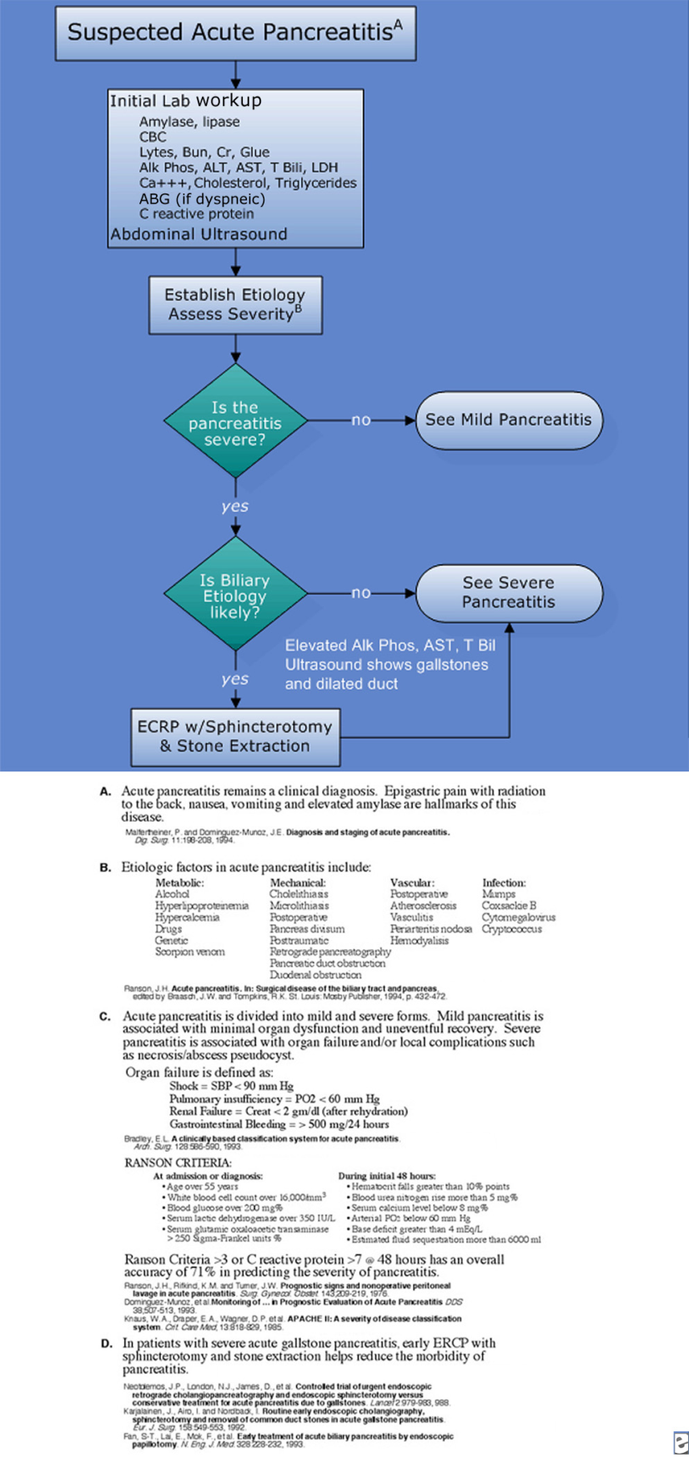
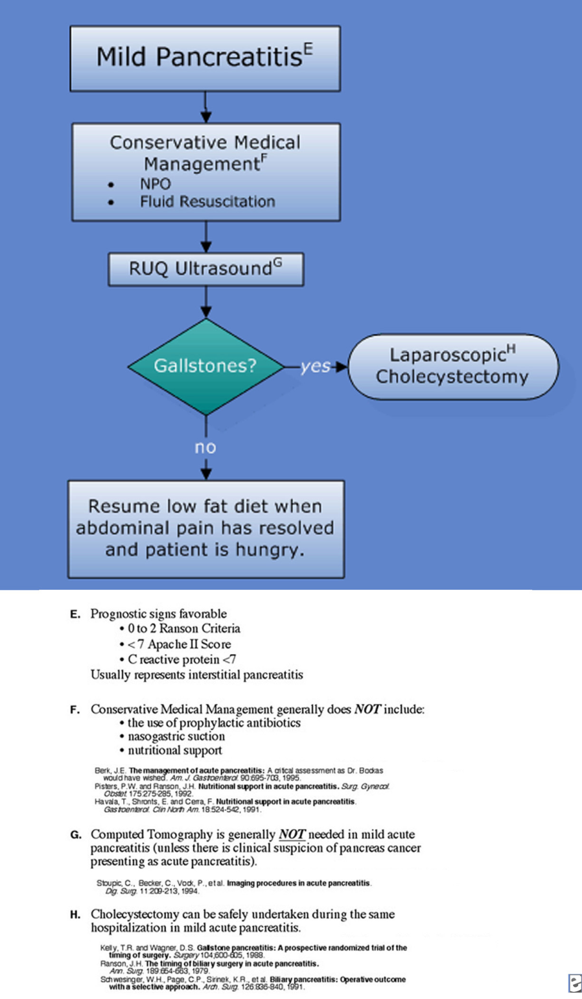
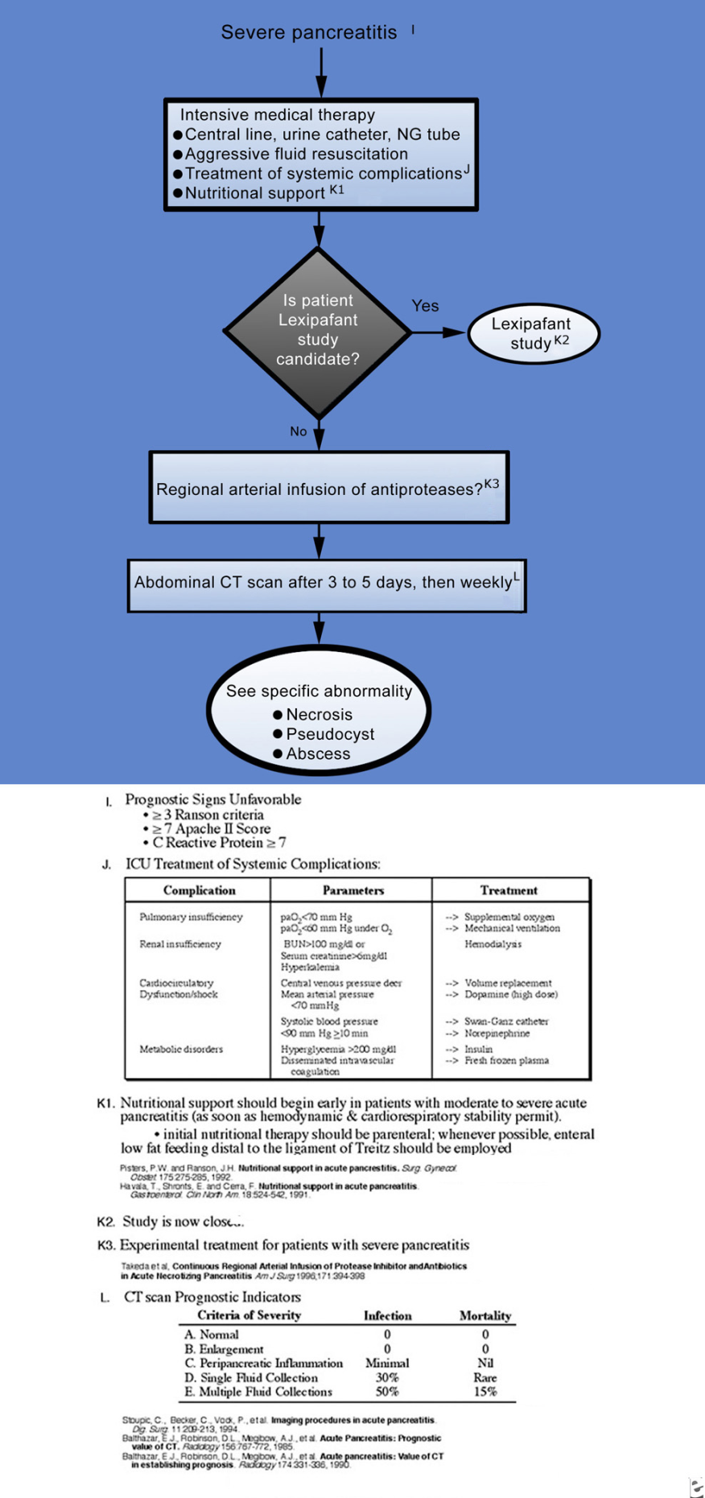
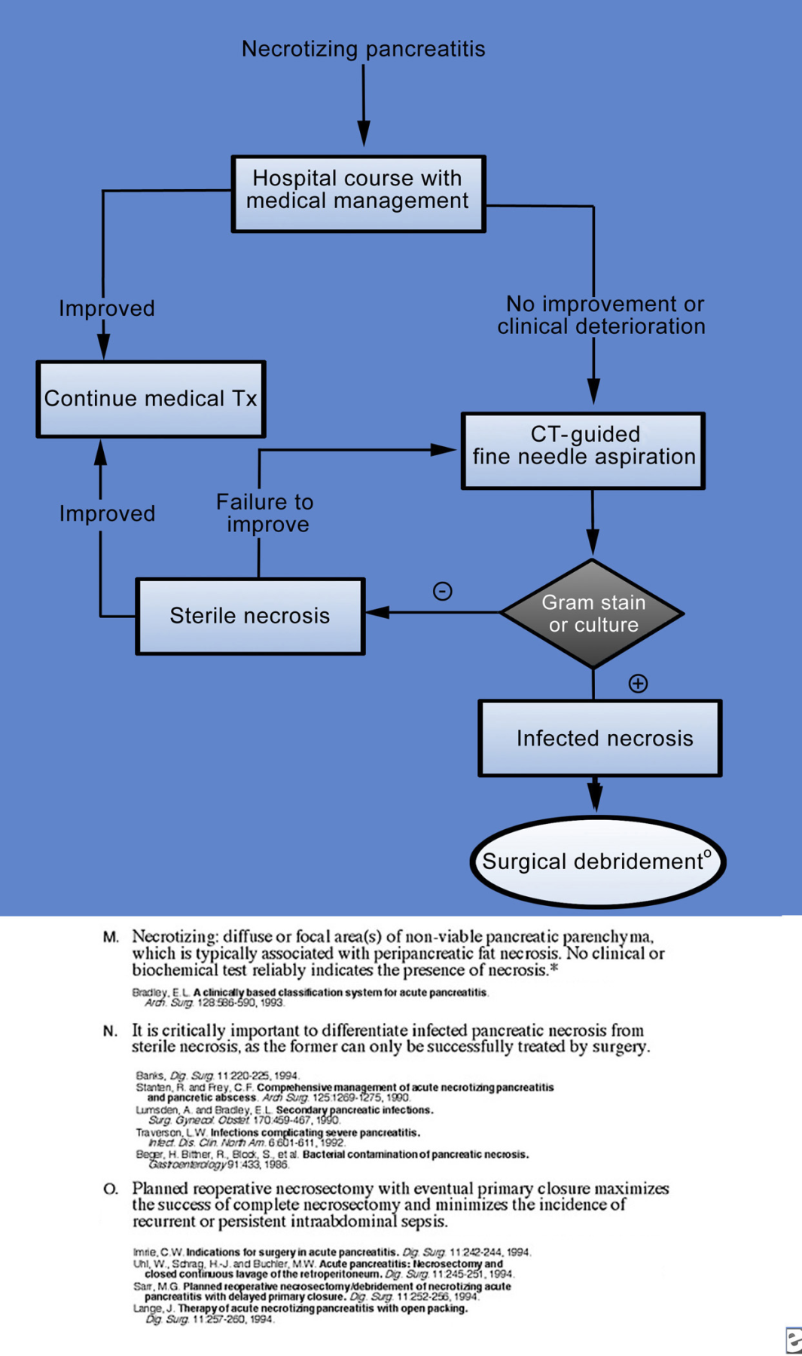
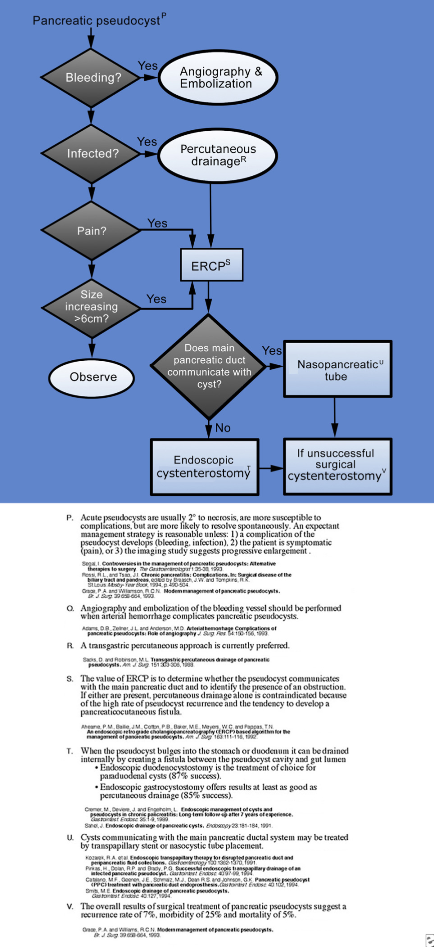
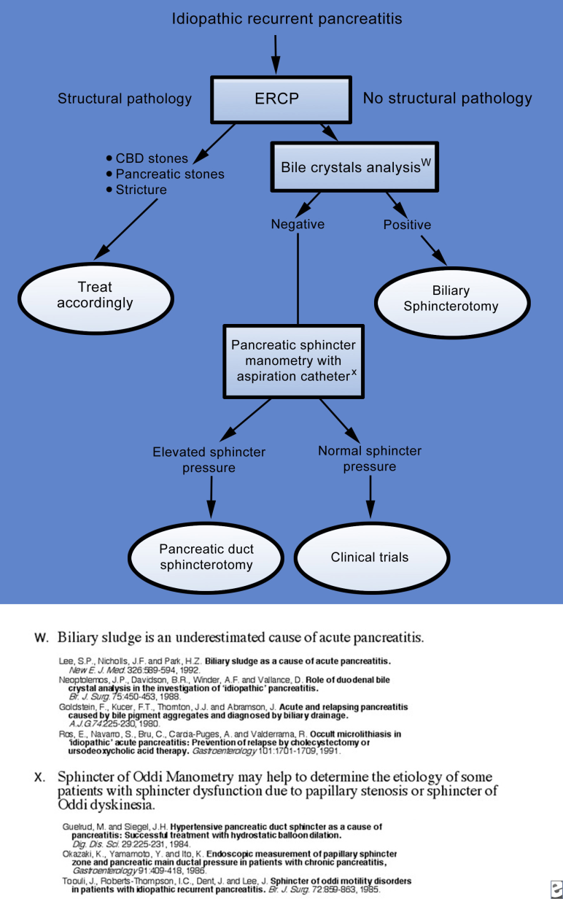
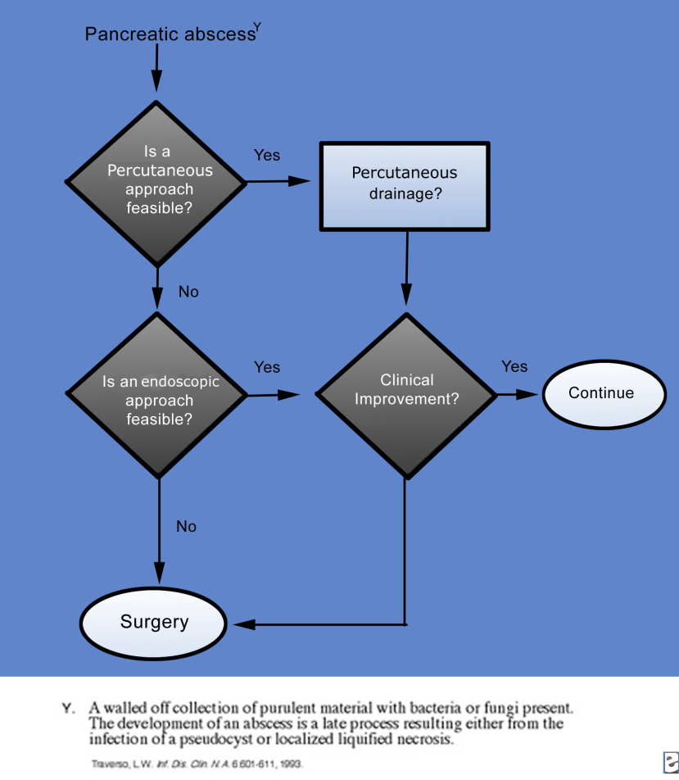
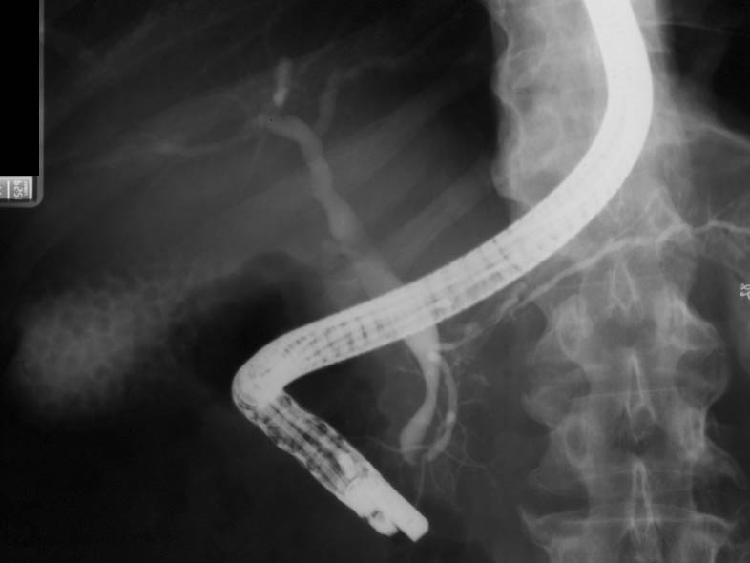
This patient with acute gallstone pancreatitis underwent endoscopic retrograde cholangiopancreatography. The cholangiogram shows no stones in the common bile duct and multiple small stones in the gallbladder. The pancreatogram shows narrowing of the pancreatic duct in the area of the genu, the result of extrinsic compression of the ductal system by inflammatory changes in the pancreas.
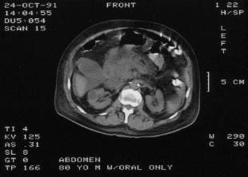

Abdominal CT scan showing pancreatic enlargement and peripancreatic fat stranding. The gallstones are not visible

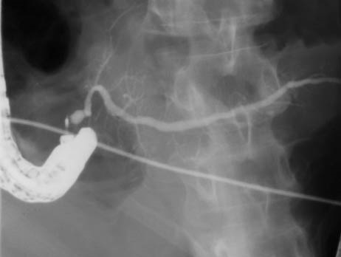
Media file 10: Pancreas divisum associated with minor papilla stenosis causing recurrent pancreatitis. Because pancreas divisum is relatively common in the general population, it is best regarded as a variant of normal anatomy and not necessarily as a cause of pancreatitis. In this case, note the bulbous contour of the duct adjacent to the cannula. This appearance has been termed a Santorinicele. A dorsal duct outflow obstruction is the probable cause of pancreatitis when a Santorinicele is present and associated with a minor papilla that accommodates only a guidewire.
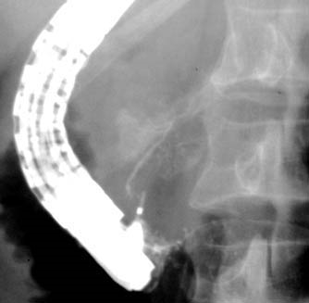
Media file 11: Normal-appearing ventral pancreas in a patient with recurrent acute pancreatitis. The dorsal pancreas (not pictured) showed evidence of chronic pancreatitis.

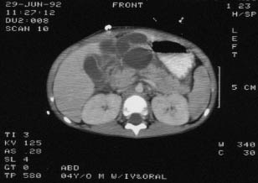
Media file 12: CT scan of the abdomen in a child with traumatic pancreatitis. The fluid collection adjacent to the pancreas will become a pseudocyst. Note that the pancreas is lacerated, nearly cut in half, by the force of the abdominal trauma. Also, note the typical location of this injury in relation to the vertebral column.
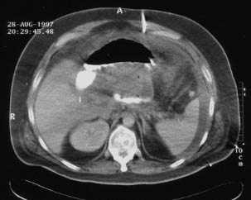
Media file 13: CT scan of a young man referred 2 weeks into his second bout of severe acute pancreatitis. He is gravely ill, with fever, leukocytosis, hypotension requiring pressors, and respiratory distress requiring mechanical ventilation. His abdominal CT scan shows severe acute pancreatitis. A percutaneous drain is placed in the dominant fluid collection to establish drainage while he is given imipenem/cilastatin and his condition is stabilized
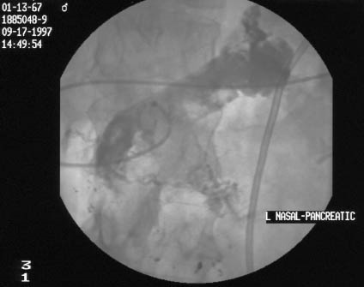
Media file 14: Endoscopic retrograde cholangiopancreatography excluded suppurative cholangitis and established the presence of anular pancreas divisum. The dorsal pancreatogram showed extravasation into the retroperitoneum, and a sphincterotomy was performed on the minor papilla. As shown in this x-ray film, a pigtailed nasopancreatic tube was then inserted into the dorsal duct and out into the retroperitoneal fluid collection. The other end of the tube was attached to the bulb suction and monitored every shift.
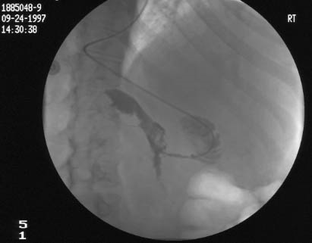
Media file 15: While percutaneous drains remove loculated fluid collections elsewhere in the abdomen, the nasopancreatic tube is containing the retroperitoneal fluid collection. One week later, the retroperitoneal fluid collection is much smaller as shown in this x-ray film (the image is reversed in the horizontal direction). By this time, the patient is off pressors and is ready to be extubated.
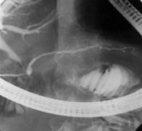

Media file 16: Four months later, after the pseudocyst has been converted into a pseudocystogastrostomy using minimally invasive techniques, the pancreatogram reveals the more proximal pancreatic duct.
- Adams DB, Zellner JL, Anderson MC. Arterial hemorrhage complicating pancreatic pseudocysts: role of angiography. J Surg Res. Feb 1993;54(2):150-6. [Medline].
- Ahearne PM, Baillie JM, Cotton PB, Baker ME, Meyers WC, Pappas TN. An endoscopic retrograde cholangiopancreatography (ERCP)-based algorithm for the management of pancreatic pseudocysts. Am J Surg. Jan 1992;163(1):111-5; discussion 115-6. [Medline].
- Balthazar EJ, Ranson JH, Naidich DP, Megibow AJ, Caccavale R, Cooper MM. Acute pancreatitis: prognostic value of CT. Radiology. Sep 1985;156(3):767-72. [Medline].
- Balthazar EJ, Robinson DL, Megibow AJ, Ranson JH. Acute pancreatitis: value of CT in establishing prognosis. Radiology. Feb 1990;174(2):331-6. [Medline].
- Banks PA. Acute pancreatitis: conservative medical management. In: Buchler MW, Halter F, Uhl W, eds. Digestive Surgery. Vol 11. Farmington, Conn: Karger; 1994:220-25.
- Banks PA, Freeman ML,. Practice guidelines in acute pancreatitis. Am J Gastroenterol. Oct 2006;101(10):2379-400. [Medline].
- Beckingham IJ, Bornman PC. ABC of diseases of liver, pancreas, and biliary system. Acute pancreatitis. BMJ. Mar 10 2001;322(7286):595-8. [Medline].
- Beger HG, Bittner R, Block S, Büchler M. Bacterial contamination of pancreatic necrosis. A prospective clinical study. Gastroenterology. Aug 1986;91(2):433-8. [Medline].
- Berk JE. Management of acute pancreatitis: critical assessment. Keio J Med. Sep 1995;44(3):93. [Medline].
- Bradley EL 3rd. A clinically based classification system for acute pancreatitis. Summary of the International Symposium on Acute Pancreatitis, Atlanta, Ga, September 11 through 13, 1992. Arch Surg. May 1993;128(5):586-90. [Medline].
- Catalano MF, Geenen JE, Schmalz MJ. Pancreatic pseudocyst (PPC) treatment with pancreatic duct endoprosthesis. Gastrointest Endosc. 1994;40:102.
- Chari ST, Smyrk TC, Levy MJ, Topazian MD, Takahashi N, Zhang L. Diagnosis of autoimmune pancreatitis: the Mayo Clinic experience. Clin Gastroenterol Hepatol. Aug 2006;4(8):1010-6; quiz 934. [Medline].
- Cremer M, Deviere J, Engelholm L. Endoscopic management of cysts and pseudocysts in chronic pancreatitis: long-term follow-up after 7 years of experience. Gastrointest Endosc. Jan-Feb 1989;35(1):1-9. [Medline].
- Domínguez-Munoz JE, Carballo F, García MJ, Miguel de Diego J, Gea F, Yangüela J, et al. Monitoring of serum proteinase--antiproteinase balance and systemic inflammatory response in prognostic evaluation of acute pancreatitis. Results of a prospective multicenter study. Dig Dis Sci. Mar 1993;38(3):507-13. [Medline].
- Eatock FC, Chong P, Menezes N, Murray L, McKay CJ, Carter CR. A randomized study of early nasogastric versus nasojejunal feeding in severe acute pancreatitis. Am J Gastroenterol. Feb 2005;100(2):432-9. [Medline].
- Fan ST, Lai EC, Mok FP, Lo CM, Zheng SS, Wong J. Early treatment of acute biliary pancreatitis by endoscopic papillotomy. N Engl J Med. Jan 28 1993;328(4):228-32. [Medline].
- Gan SI, Romagnuolo J. Admission hematocrit: a simple, useful and early predictor of severe pancreatitis. Dig Dis Sci. Nov-Dec 2004;49(11-12):1946-52. [Medline].
- Goldstein F, Kucer FT, Thornton JJ 3rd, Abramson J. Acute and relapsing pancreatitis caused by bile pigment aggregates and diagnosed by biliary drainage. Am J Gastroenterol. Sep 1980;74(3):225-30. [Medline].
- Grace PA, Williamson RC. Modern management of pancreatic pseudocysts. Br J Surg. May 1993;80(5):573-81. [Medline].
- Guelrud M, Siegel JH. Hypertensive pancreatic duct sphincter as a cause of pancreatitis. Successful treatment with hydrostatic balloon dilatation. Dig Dis Sci. Mar 1984;29(3):225-31. [Medline].
- Havala T, Shronts E, Cerra F. Nutritional support in acute pancreatitis. Gastroenterol Clin North Am. Sep 1989;18(3):525-42. [Medline].
- Imrie CW. Indications for surgery in acute pancreatitis. Dig Surg. 1994;11:242-4.
- Jacobson E, Assareh H, Cannerfelt R, Anderson RE, Jakobsson JG. The postoperative analgesic effects of intra-articular levobupivacaine in elective day-case arthroscopy of the knee: a prospective, randomized, double-blind clinical study. Knee Surg Sports Traumatol Arthrosc. Feb 2006;14(2):120-4. [Medline].
- Karjalainen J, Airo I, Nordback I. Routine early endoscopic cholangiography, sphincterotomy and removal of common duct stones in acute gallstone pancreatitis. Eur J Surg. Oct 1992;158(10):549-53. [Medline].
- Kelly TR, Wagner DS. Gallstone pancreatitis: a prospective randomized trial of the timing of surgery. Surgery. Oct 1988;104(4):600-5. [Medline].
- Khan Z, Vlodov J, Horovitz J, Jose RM, Iswara K, Smotkin J. Urinary trypsinogen activation peptide is more accurate than hematocrit in determining severity in patients with acute pancreatitis: a prospective study. Am J Gastroenterol. Aug 2002;97(8):1973-7. [Medline].
- Knaus WA, Draper EA, Wagner DP, Zimmerman JE. APACHE II: a severity of disease classification system. Crit Care Med. Oct 1985;13(10):818-29. [Medline].
- Kozarek RA, Ball TJ, Patterson DJ, Freeny PC, Ryan JA, Traverso LW. Endoscopic transpapillary therapy for disrupted pancreatic duct and peripancreatic fluid collections. Gastroenterology. May 1991;100(5 Pt 1):1362-70. [Medline].
- Lankisch PG, Mahlke R, Blum T, Bruns A, Bruns D, Maisonneuve P. Hemoconcentration: an early marker of severe and/or necrotizing pancreatitis? A critical appraisal. Am J Gastroenterol. Jul 2001;96(7):2081-5. [Medline].
- Lee SP, Nicholls JF, Park HZ. Biliary sludge as a cause of acute pancreatitis. N Engl J Med. Feb 27 1992;326(9):589-93. [Medline].
- Lumsden A, Bradley EL 3rd. Secondary pancreatic infections. Surg Gynecol Obstet. May 1990;170(5):459-67. [Medline].
- Malfertheiner P, Dominguez-Munoz JE. Diagnosis and staging of acute pancreatitis. Dig Surg. 1994;11:198-208.
- Mann DV, Hershman MJ, Hittinger R, Glazer G. Multicentre audit of death from acute pancreatitis. Br J Surg. Jun 1994;81(6):890-3. [Medline].
- Nathens AB, Curtis JR, Beale RJ, Cook DJ, Moreno RP, Romand JA. Executive summary: management of the critically ill patient with severe acute pancreatitis. Proc Am Thorac Soc. 2004;1(4):289-90. [Medline].
- National Center for Health Statistics. National hospital discharge survey: 2002 annual summary with detailed diagnosis and procedure data. Series Report 13. 2003;No. 158 (PHS 2005-1729):207.
- Neoptolemos JP, Carr-Locke DL, London NJ, Bailey IA, James D, Fossard DP. Controlled trial of urgent endoscopic retrograde cholangiopancreatography and endoscopic sphincterotomy versus conservative treatment for acute pancreatitis due to gallstones. Lancet. Oct 29 1988;2(8618):979-83. [Medline].
- Neoptolemos JP, Davidson BR, Winder AF, Vallance D. Role of duodenal bile crystal analysis in the investigation of 'idiopathic' pancreatitis. Br J Surg. May 1988;75(5):450-3. [Medline].
- Neoptolemos JP, Raraty M, Finch M. Acute pancreatitis: the substantial human and financial costs. Gut. 1988;42(6):886-91.
- Okazaki K, Yamamoto Y, Ito K. Endoscopic measurement of papillary sphincter zone and pancreatic main ductal pressure in patients with chronic pancreatitis. Gastroenterology. Aug 1986;91(2):409-18. [Medline].
- Pandol SJ, Saluja AK, Imrie CW, Banks PA. Acute pancreatitis: bench to the bedside. Gastroenterology. Mar 2007;132(3):1127-51. [Medline].
- Pinkas H, Dolan RP, Brady PG. Successful endoscopic transpapillary drainage of an infected pancreatic pseudocyst. Gastrointest Endosc. Jan-Feb 1994;40(1):97-9. [Medline].
- Pisters PW, Ranson JH. Nutritional support for acute pancreatitis. Surg Gynecol Obstet. Sep 1992;175(3):275-84. [Medline].
- Ranson J H. Acute pancreatitis. In: Braasch JW, ed. Surgical Disease of the Biliary Tract and Pancreas. St. Louis, Mo: Mosby; 1994:432-72.
- Ranson JH. The timing of biliary surgery in acute pancreatitis. Ann Surg. May 1979;189(5):654-63. [Medline].
- Ranson JH, Rifkind KM, Turner JW. Prognostic signs and nonoperative peritoneal lavage in acute pancreatitis. Surg Gynecol Obstet. Aug 1976;143(2):209-19. [Medline].
- Ros E, Navarro S, Bru C, Garcia-Pugés A, Valderrama R. Occult microlithiasis in 'idiopathic' acute pancreatitis: prevention of relapses by cholecystectomy or ursodeoxycholic acid therapy. Gastroenterology. Dec 1991;101(6):1701-9. [Medline].
- Rossi R L, Tsao J I. Chronic pancreatitis: complications. In: Surgical Disease of the Biliary Tract and Pancreas. St. Louis, Mo: Mosby-Year Book; 1994:490-504.
- Sacks D, Robinson ML. Transgastric percutaneous drainage of pancreatic pseudocysts. AJR Am J Roentgenol. Aug 1988;151(2):303-6. [Medline].
- Sahel J. Endoscopic drainage of pancreatic cysts. Endoscopy. May 1991;23(3):181-4. [Medline].
- Sarr MG. Planned reoperative necrosectomy/debridement of necrotizing acute pancreatitis and delayed primary closure. Dig Surg. 1994;11:252-6.
- Schwesinger WH, Page CP, Sirinek KR, Levine BA, Aust JB. Biliary pancreatitis. Operative outcome with a selective approach. Arch Surg. Jul 1991;126(7):836-9; discussion 839-40. [Medline].
- Segal I. Controversies in the management of pancreatic pseudocysts: alternative therapies to surgery. Gastroenterologist. Mar 1993;1(1):34-8. [Medline].
- Smits ME. Endoscopic drainage of pancreatic pseudocysts. Gastrointest Endosc. 1994;40:127.
- Stanten R, Frey CF. Comprehensive management of acute necrotizing pancreatitis and pancreatic abscess. Arch Surg. Oct 1990;125(10):1269-74; discussion 1274-5. [Medline].
- Stelzner M, Pellegrini C. The treatment of gallstone pancreatitis. Adv Surg. 1999;33:163-79. [Medline].
- Stoupis C, Becker C, Vock P. Imaging procedures in acute pancreatitis. Dig Surg. 1994;11:209-13.
- Toouli J, Roberts-Thomson IC, Dent J, Lee J. Sphincter of Oddi motility disorders in patients with idiopathic recurrent pancreatitis. Br J Surg. Nov 1985;72(11):859-63. [Medline].
- Traverson LW. Infections complicating severe pancreatitis. Infec Dis Clin North Am. 1992;6:601-11.
- Uhl W, Schrag HJ, Buchler MW. Acute pancreatitis: Necrosectomy and closed continuous lavage of the retroperitoneum. Dig Surg. 1994;11:245-51.
- Whitcomb DC. Clinical practice. Acute pancreatitis. N Engl J Med. May 18 2006;354(20):2142-50. [Medline].

